Beier, Ulli (1922-2011)

Ulli Beier (b. 1922, Glowitz, Poland - d. 2011, Sydney, Australia) was a Polish-born, publisher, writer, translator, lecturer, curator, theatre producer and particularly a promoter and collector of arts. Throughout his career, Beier’s interests shifted between Aboriginal Art in Australia, outsider art in India and Papua New Guinea, but the focus of his life’s work was centred in Nigeria, where he would come to shape the arts as one of the first outsiders to recognize and support the emerging modern art movement in this country. By promoting and collecting traditional and modern art he shaped a very specific image of Africa. Beier’s initiatives such as the ‘Black Orpheus’ magazine, the Mbari-Club in Ibadan and the Mbari-Mbayo-Club in Osogbo helped new forms of African art to develop a voice and aesthetic. From 1981-1996, Beier was the director of the Center of African Culture at the University in Bayreuth, the Iwalewa-Haus, where he continued to promote art from all over the world, in exhibitions, festivals and publications, until he retired with his wife Georgina Beier to Sydney, Australia where he died in 2011.

Ulli Beier was born 1922 in Glowitz (Pomerania), nowadays Poland, the son of a Jewish physician. He grew up in Berlin, but when the National Socialist Party seized power in Germany, the family moved to Palestine in 1933. At that time, Ulli Beier completed a distance course in special needs education carried out in London, where he later finished his studies in phonetics. In 1949 he met the Austrian artist Susanne Wenger (1915-2009) in Paris and married her in the same year.
In October 1950, Beier went with Wenger to Nigeria where he taught English phonetics at the University of Ibadan. Once settled in Nigeria, Beier claims his life properly began. In the same year, Beier visited a mental institution in Abeokuta and provided the patients with paint and paper. Being aware of the Art Brut Movement in Paris, which was a label for art outside of the official cultural boundaries, he began to collect the works produced by his pupils.
Beier and Wenger became learned and practiced in the Yoruba language and culture, and able to mediate culturally between Africa and Europe. Beier wrote down orally transmitted Yoruba plays and stories in English, translated European plays into Yoruba and emerged as one of the scholars who introduced African writers to a large international audience. He documented the religious life of the Yoruba, collected their cultural works and gained the chief title of Bobagunwa as the spokesperson for young actors, musicians and artists. Beier considered himself the preserver of a culture that was in danger of disappearing, but he was also aware of a new emerging African art, which he would address in his publication of 1968, Contemporary Art in Africa. Here he presented one of the first acknowledgments of individual artists, which helped redirect a traditional ethnographic view of African Arts towards a modern concept.
In 1957, he founded the literary magazine ‘Black Orpheus: A Journal of African and Afro-American Literature’ together with Janheinz Jahn, Wole Soyinka and Chinua Achebe, providing a platform to propagate African literature. In 1961, he co-founded the ‘Mbari-Club’ in Ibadan, which was a meeting place for intellectuals and artists of any kind. In 1962 the ‘Mbari-Mbayo-Club’, housed in the childhood home of the Yoruba dramatist Duro Ladipo, was opened in Osogbo.
In 1963, the painter and sculptor Georgina Betts (b. 1938) came to Nigeria and shortly afterwards she became Ulli Beier’s second wife. By 1964, Georgina was conducting the annual art workshop at the Mbari-Mbayo-Club, the starting point for the formation of the Osogbo Art School.
In 1967 the Beiers moved to Papua-New Guinea. As professor at the University of Papua New Guinea in Port Moresby, Ulli Beier fostered writers, whereas Georgina encouraged New Guineans to take up the visual arts. During their stay in Papua New Guinea pieces of their Nigerian art collection were shown in Europe and the United States.
During the seventies, the couple relocated frequently between Papua New Guinea, Nigeria, and Sydney, Australia, ultimately ending up in Germany. An exhibition of African Art produced by Ulli Beier at the University in Mainz in 1997 was so successful that Klaus-Dieter Wolff, the founding president of the University of Bayreuth, offered Beier the directorate of a centre for modern African Art at the University. Ulli Beier accepted the position when it was agreed that the centre would function not only as a museum of contemporary art and culture from Africa and other non-Western countries but also as an art gallery and artist residency program (Obafemi, 1993: 30).

In 1981 Beier was officially elected the director of this centre named Iwalewa-Haus after the Yoruba phrase ‘character is beauty’. Beiers invited artists and friends from all over the world to come and exhibit their works; here they lived together with their collection of modern art from Nigeria, Papua New Guinea and Australia. With that he expanded the collection and made the institute into a nationally and internationally recognized address. Beier held the director position until 1996.
In 1997 the Beiers left Germany for good and moved to Sydney, where they became interested in Aboriginal art. Ulli Beier died in Sydney in 2011.

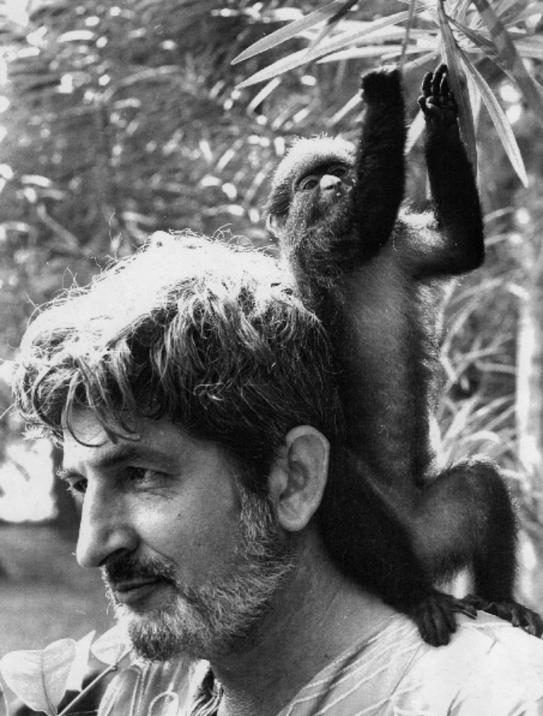
Ulli Beier, c. 1965
Copyrights: DEVA und Iwalewa-Haus, Universität Bayreuth; Center for Black Culture and International Understanding (CBCIU), Osogbo, Nigeria
*No URL for this image, author procured it direct from Iwalewa Haus: contact Iwalewa directly for copyright
Iwalewa-Haus

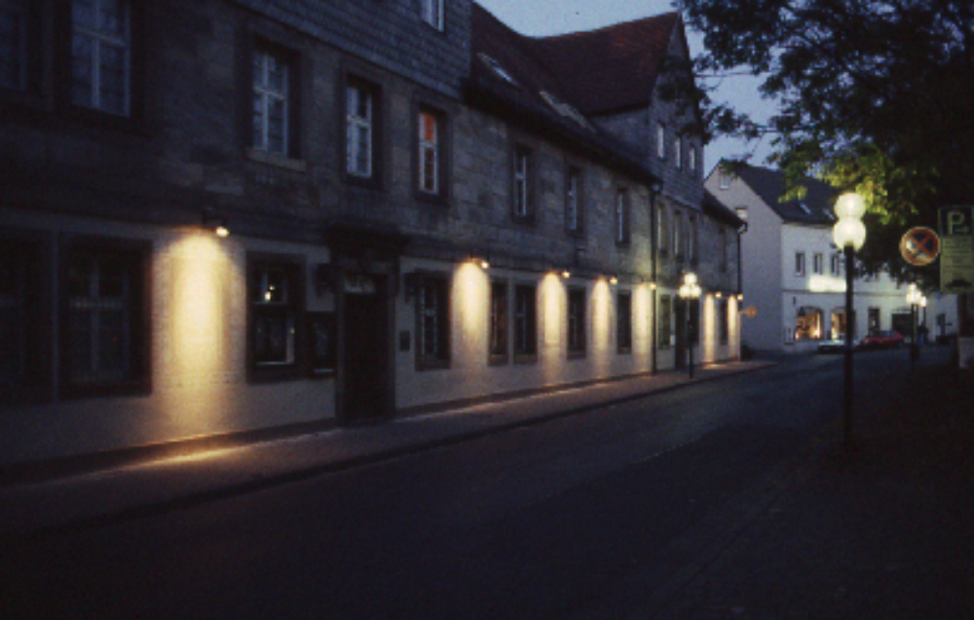
Copyrights: DEVA und Iwalewa-Haus, Universität Bayreuth; Center for Black Culture and International Understanding (CBCIU), Osogbo, Nigeria

http://www.iwalewa.uni-bayreuth.de/de/index.html

References and further reading

Beier, Ulli (1968), Contemporary Art in Africa, New York – Washington – London: Frederick A.
Praeger
- (1982), Glücklose Köpfe: Malerei von Ver-rückten aus Nigeria, Bremen: CON
- (1994), The Return of Shango, The Theatre of Duro Ladipo, Bayreuth: Iwalewa-Haus –
University of Bayreuth
Deliss, Clèmentine (ed.) (1995), Seven Stories About Modern Art in Africa, London: Whitechapel
Enwezor, Okwui (et al.) (2001), The Short Century: Independence and Liberation Movements in Africa 1945-1994,
Munich - London - New York: Prestel
Kasfir, Sidney Littlefield (1999), Contemporary African Art, London: Thames 6 Hudson Ltd.
Larson, Charles R. (1972), ‘Ulli Beier: African Playwright ?' Books Abroad. Vol. 46, No 3, pp. 393 – 396,
Norman: Board of Regents of the University of Oklahoma
Ogundele, Wole (2003), Omoluabi: Ulli Beier, Yoruba Society and Culture, Bayreuth: Bayreuth University
Ogundele, Wole (ed.) (2001), Character is Beauty: Redefining Culture and Identity (Iwalewa-Haus, 1981-1996),
Trenton – Asmara: Africa World Press
Pivin, Jean Loup (ed.) (2002), An Anthology of African Art: The Twentieth Century, New York: Distributed
Art Publishers
Probst, Peter (2011), Osogbo and the Art of Heritage, Monuments, Deities, and Money, Bloomington: Indiana
University Press

